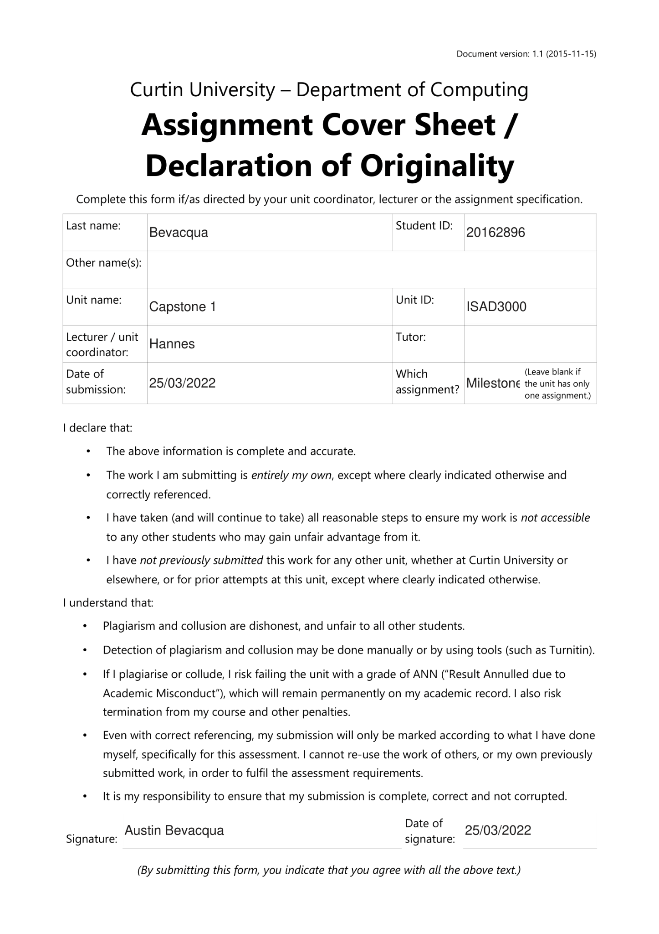

*ISAD3000 Capstone Computing Project Milestone 2 Individual Report*

***Austin Bevacqua***

***Group E8: Amristar Industry Project [Virtual Jukebox]***

Group Members:

Austin Bevacqua, Bradley van der Zwan, Dillon Vincent,   
Ryan Webster, Tanaka Chitete

## 

## 

## 

## 

## Progress Tracking

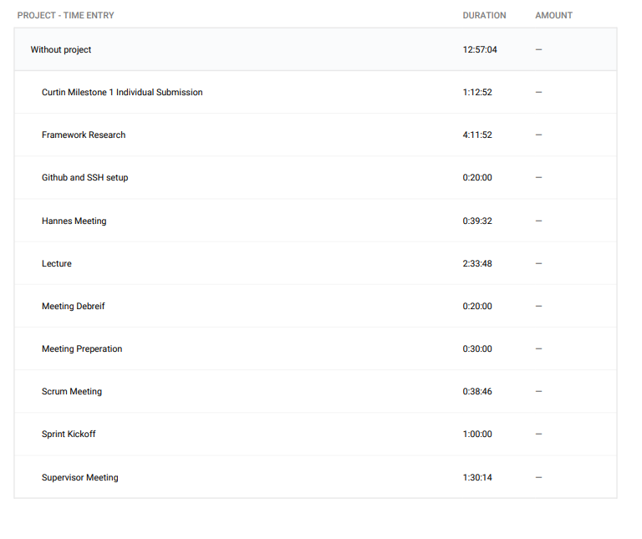

**Supervisor Meetings (15 March, 21 March)**

Our initial supervisor meeting with Andrew was held at Kings Park, where we were given an overview of the project. Every group member had questions to ask , and Bradley took down minutes for this meeting.

Our second supervisor meeting with Andrew was held the week after online, where he was checking up on our progress and individually asked us for updates, much like a standup meeting. Bradley also took minutes for this meeting.

**Sprint Kickoff (15 March)**

After our initial meeting with Andrew, we decided to kick off our sprint. We settled on 2-week sprints, as this worked nicely with Amristars 4-week submission milestones. For our first sprint, we decided to independently conduct research on separate areas of technologies, including databases, streaming API’s ect. I was assigned to research frontend and backend frameworks. We entered all group tasks as tickets on Jira, and once again Bradley wrote out Minutes for this meeting.

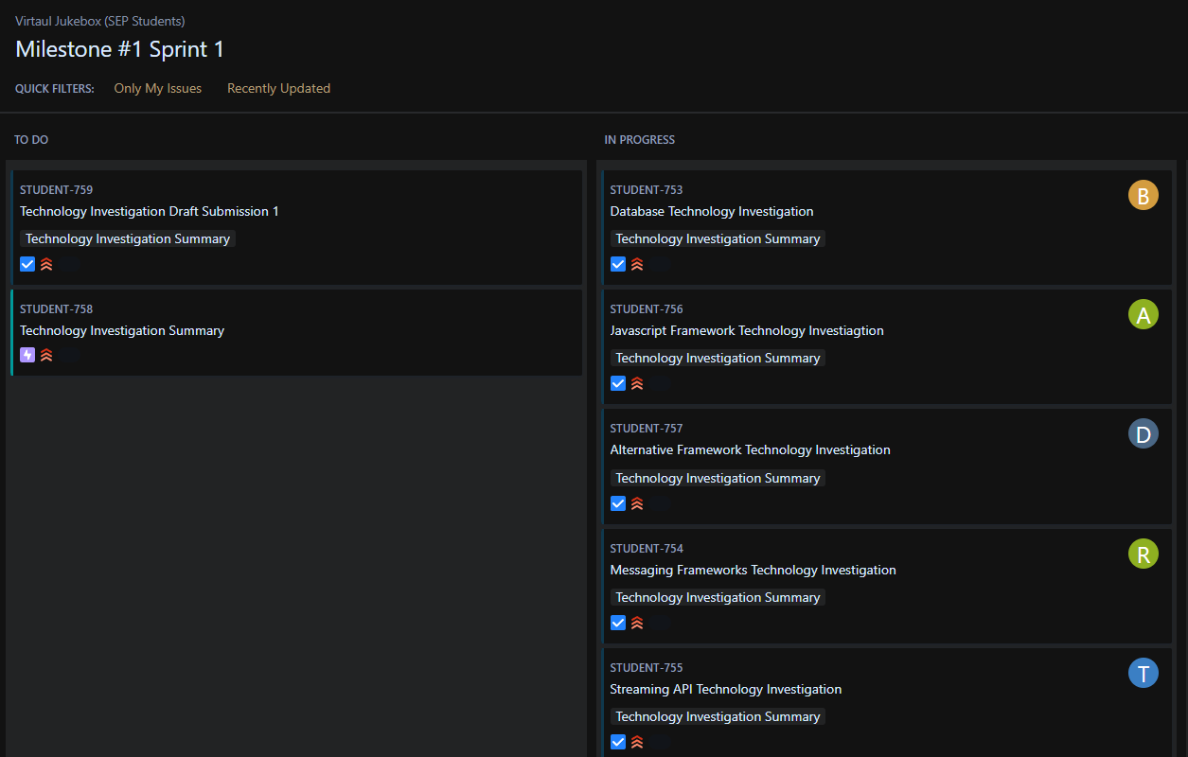

**Scrum Meetings (18 March, 20 March, 23 March)**

Scrum meetings were run and organised by myself. Each meeting consists of the following questions:

What have you been doing? What are you currently doing? What will you be doing? Are you having problems with anything?

Answers to these questions were written down by Bradley, who has included these documents in this report. We also used the scrum meeting times to discuss submissions, meetings with supervisors and when the next meeting would take place. The next Scrum meeting is scheduled for today (25th).

**Lectures (15 March, 22 March)**

I watched both Aneesh’s Scrum lecture on the 15th and Hannes’ SRS workshop on the 22nd. Bradley and myself used the time after the workshop to talk about the Curtin submissions, scrum progress, and exchange research on investigated technologies.

**Technology Investigation (15th March - 29th March)**

After the sprint kickoff, I was assigned to do research into frontend and backend frameworks for the technology investigation. All my work was done on the cloud on Google slides, so all times I edited the document are visible.

Frontend Technology investigation <https://docs.google.com/presentation/d/1qGjtVOsfglGwDRRtJJ-COLKPchtvUG0RCZ7N68MP920/edit?usp=sharing>

Backend Technology Investigation <https://docs.google.com/presentation/d/1V9lEM1aUGhMTJdL-NAEP3zJnzHv1uPppNCGQk29qTRM/edit?usp=sharing>

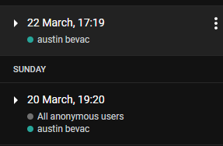

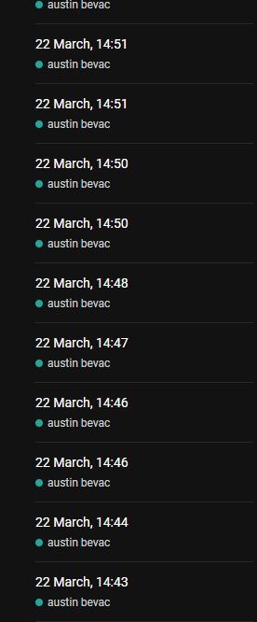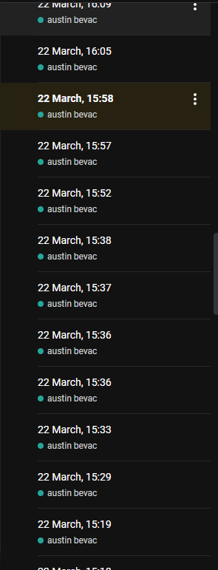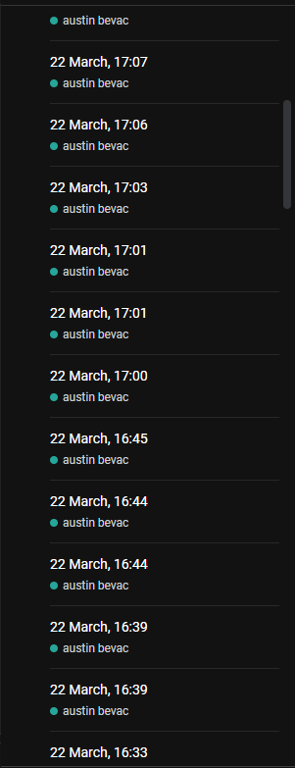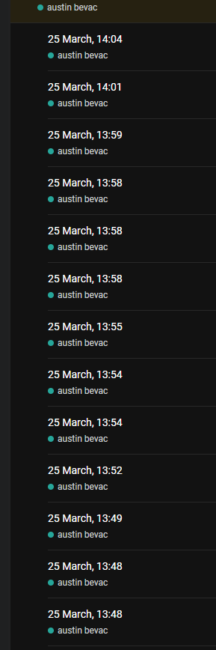

**Curtin Milestone 1 Individual Submission (25th March)**

This document

## Summary

I am on track to complete all my tasks for this sprint. The technology investigation for frontend and backend frameworks is going extremely well, as Dillon and I have collated information on 10 different front end frameworks, and 7 different back end frameworks. By the end of the sprint, we aim to have the research completed, and a draft technology investigation submitted.

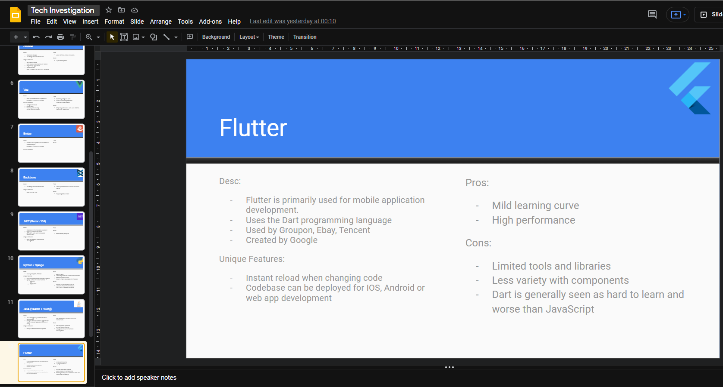

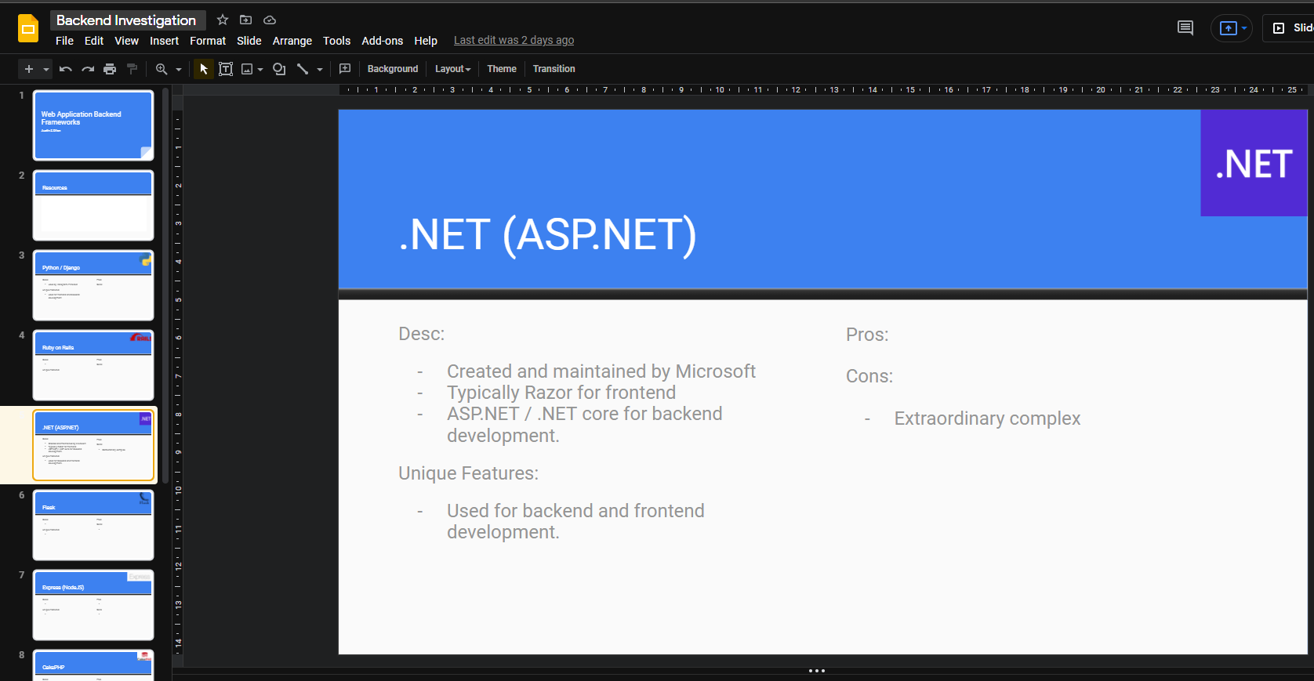

As group elected scrum master, I am in charge of organising the scrum kickoffs, scrum standups and retrospectives. Finding a time to host stand-ups which everyone can attend has been difficult, but will only get easier as time progresses. As a group, we have been regularly communicating what we are doing and what we still need to do, which makes following the agile process significantly easier.

It has been very difficult remembering to enable Toggl to time work and meetings, but I am getting more in the habit as time goes on. I plan to do roughly 4 hours of research work today and on the weekend, which will make up my 10 hours for the week.